Welcome to Module 6 of the IOD Software Engineering course!
This is a handy guide to help students make sure their lab work is easily understood and completed. Make sure to ask your trainers if you have any questions about how to complete these exercises.
Trainers will release answers once everyone has had a chance to complete them, but often there are many possible answers so don’t worry if yours are different. The extensions are not required but are strongly recommended to reinforce the learning in this module.
Create a repositoryr Module 6 that you can include in a GitHub repository. You may wish to re-use the same private repo from previous modules and include a new folder in there, or create a separate private repo. Group all Module 6 exercises in the same folder, in the same React application, with appropriate naming to make them easy to find. Ensure your trainer/s have access.

Lab Exercise 1: | Slide 31

Instructions: Follow the instructions on the slide to create a Greeting component that supports props and children, and render it in App.jsx.
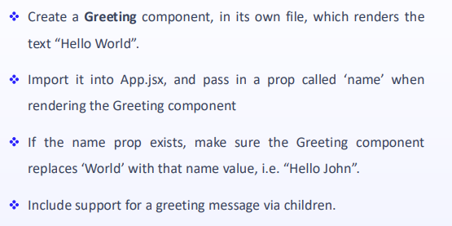
Goal: To practise creating a React component that uses props and children.
Submission: Create a React app in your Module 6 Lab Exercises repository. Save the component in a file called Greeting.jsx inside this React app, ideally inside a folder called components.
Extension: Read through the links below and do the challenges at the end.
Resources & Extra Learning:
- https://react.dev/learn/your-first-component
- https://react.dev/learn/importing-and-exporting-components
- https://react.dev/learn/writing-markup-with-jsx
- https://react.dev/learn/javascript-in-jsx-with-curly-braces
- https://react.dev/learn/passing-props-to-a-component
- https://react.dev/learn/conditional-rendering

Lab Exercise 2: | Slide 47

Instructions: Follow the instructions on the slide to create a BigCats component to display data from the given array. Add unique IDs to the array and fix the warning about keys. Create a SingleCat component rendered by BigCats for each individual cat. Render BigCats from App.jsx.
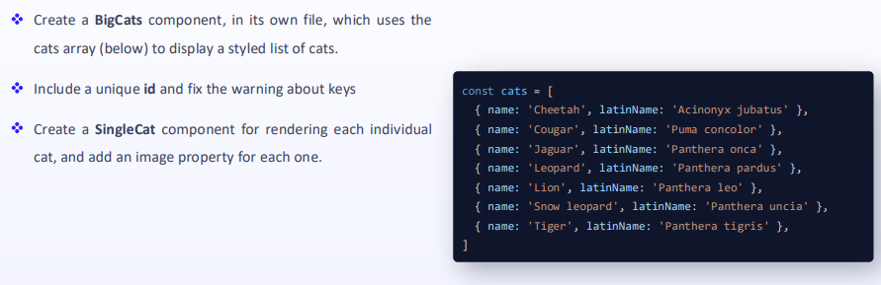
Goal: To practise creating React components that render a list of items using best practice techniques.
Submission: Save the components in BigCats.jsx and SingleCat.jsx files inside the React app in your Module 6 Lab Exercises repository.
Extension: Read through the links below and do the challenges at the end.
Resources & Extra Learning:
- https://react.dev/learn/rendering-lists
- https://react.dev/learn/keeping-components-pure
- https://react.dev/learn/understanding-your-ui-as-a-tree

Lab Exercise 3: | Slide 57

Instructions: Follow the instructions on the slide to create an Emoji component which renders an emoji as well as a button to change/switch the emoji. Render Emoji from App.jsx.
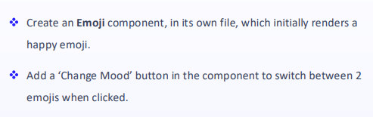
Goal: To practise creating React components that use state to provide a dynamic interface that changes in response to a user action.
Submission: Save the component in a file called Emoji.jsx inside the React app in your Module 6 Lab Exercises repository.
Extension: Read through the links below and do the challenges at the end.
Resources & Extra Learning:
- https://react.dev/learn/adding-interactivity
- https://react.dev/learn/responding-to-events
- https://react.dev/learn/state-a-components-memory
- https://react.dev/learn/render-and-commit
- https://react.dev/learn/state-as-a-snapshot

Lab Exercise 4: | Slide 72

Instructions: Follow the instructions on the slide to extend the BigCats component from Exercise 2 to include sorting and filtering buttons which dynamically change the output of the component.
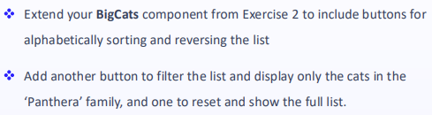
Goal: To practise creating React components that use state to provide a dynamic interface that changes in response to a user action.
Submission: Save the updated BigCats.jsx component inside the React app in your Module 6 Lab Exercises repository.
Extension: Read through the links below and do the challenges at the end.
Resources & Extra Learning:
- https://react.dev/learn/reacting-to-input-with-state
- https://react.dev/learn/choosing-the-state-structure
- https://react.dev/learn/sharing-state-between-components
- https://react.dev/learn/preserving-and-resetting-state
- https://react.dev/learn/updating-arrays-in-state

Lab Exercise 5: | Slide 80

Instructions: Follow the instructions on the slide to create an AddCatForm component which renders a form containing fields for a new Big Cat. Submitting the form should use the submitted data to add a new cat to the list displayed by BigCats from Exercises 2 & 4. Render AddCatForm from BigCats.jsx.
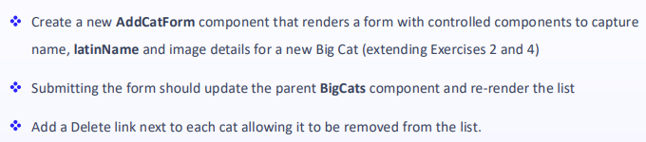
Goal: To practise creating React components that use state to manage form fields.
Submission: Save the component in a file called AddCatForm.jsx inside the React app in your Module 6 Lab Exercises repository.
Extension: Read through the links below and do the challenges at the end.
Resources & Extra Learning:
- https://react.dev/learn/updating-objects-in-state
- https://react.dev/reference/react-dom/components/input
- https://react.dev/reference/react-dom/components/select

Lab Exercise 6: | Slide 89

Instructions: Follow the instructions on the slide to create a Calculator component which renders a basic calculator supporting 2 digits and a choice of operator. Follow the ‘Thinking in React’ process while designing and choosing your component structure.
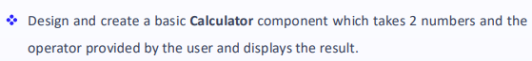
Goal: To practise creating a small React application containing multiple components and support for state that follows React best practices.
Submission: Save the component in a file called Calculator.jsx inside the React app in your Module 6 Lab Exercises repository. Any additional components should use appropriate naming conventions.
Extension: Read through the links below and do the challenges at the end.
Resources & Extra Learning:
- https://react.dev/learn/thinking-in-react
- https://react.dev/learn/tutorial-tic-tac-toe

